Name: Pranali Sonawane
Subject: MCSA
Date: 3-12-2025
Lab :User Creation (Client )IP addressing,Renaming ,Password and Ping work check firewall turned off
Server 1:
1. Edit VM Settings NA Custom VMnet2
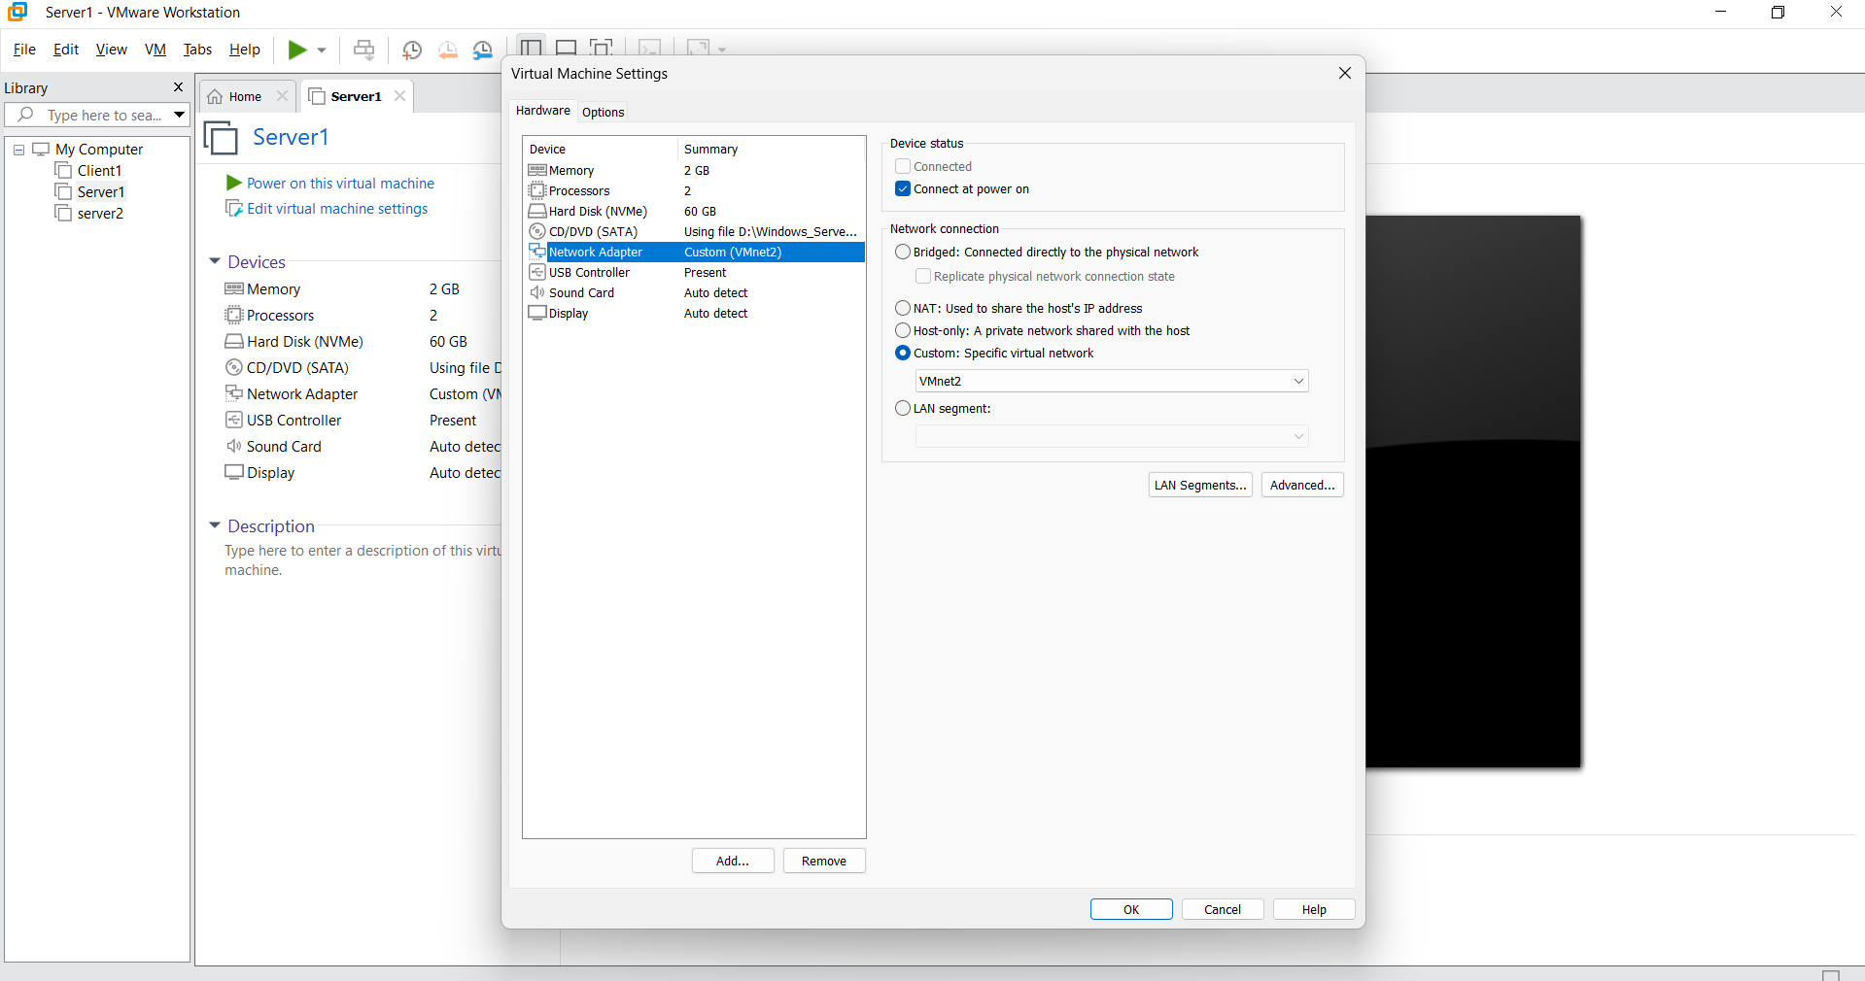
2.Power on VM :
Local Server Computer Name server1 rename the computer name server1
Go to the local Server Windows Firewall Turned OFF
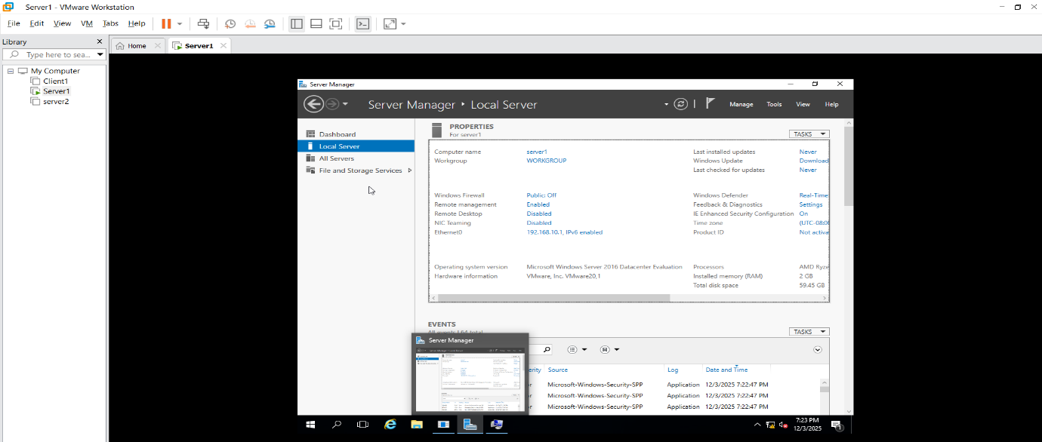

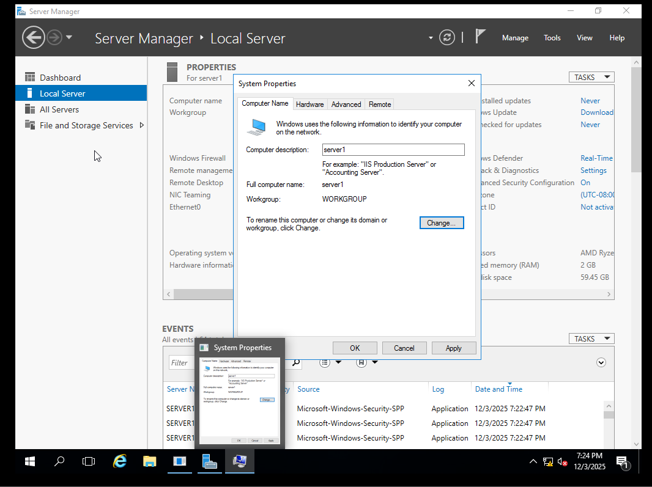
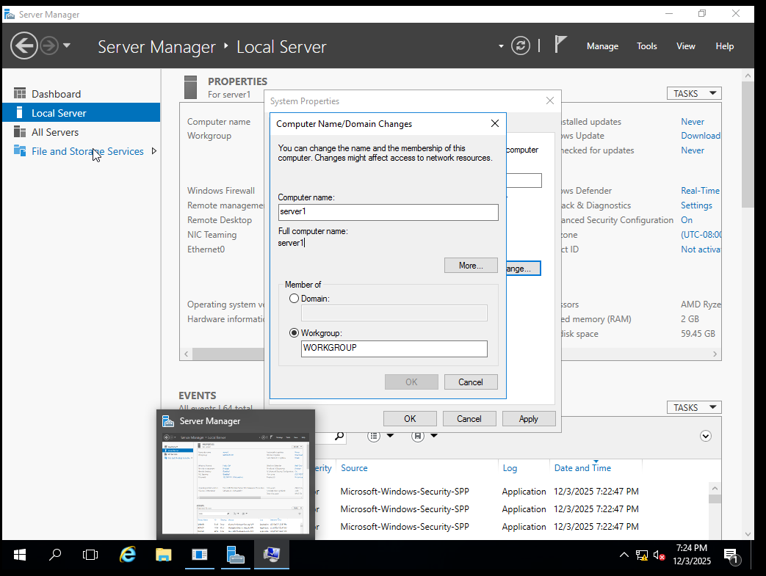
3. Ethernet0
Ethernet0 Properties IPV4 Give the ip : – 192.168.10.1 click on subnet mask Preffered DNS Server : 192.168.10.1

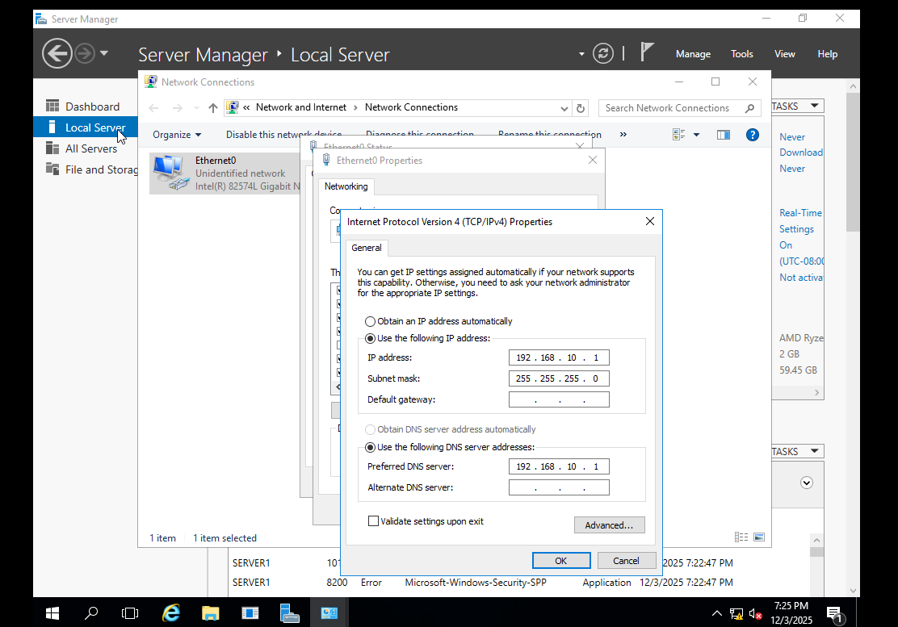
Server 2:
1. Edit VM Settings NA Custom VMnet2
2.Power on VM :Local Server Computer Name server2 rename the computer name server2
3. Go to the local Server Windows Firewall Turned OFF
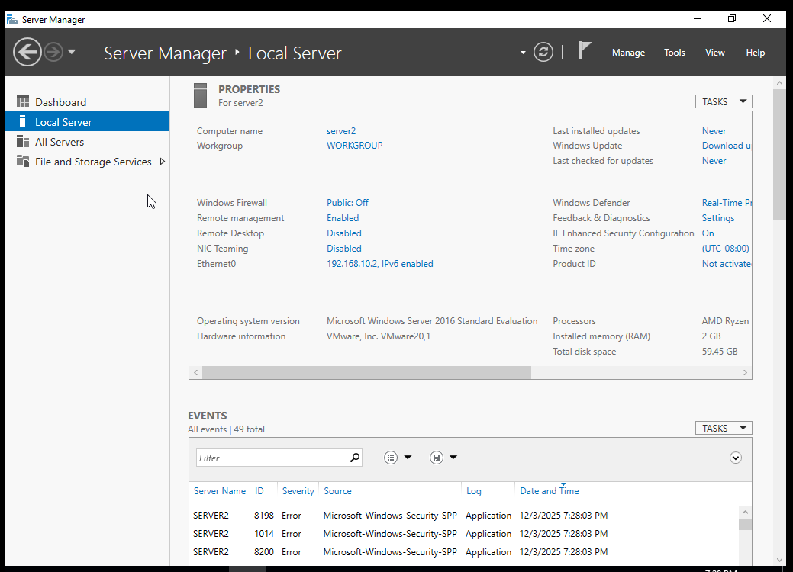
3. Ethernet0: Ethernet0 Properties IPV4 Give the ip : – 192.168.10.2 click on subnet mask Preffered DNS Server : 192.168.10.1
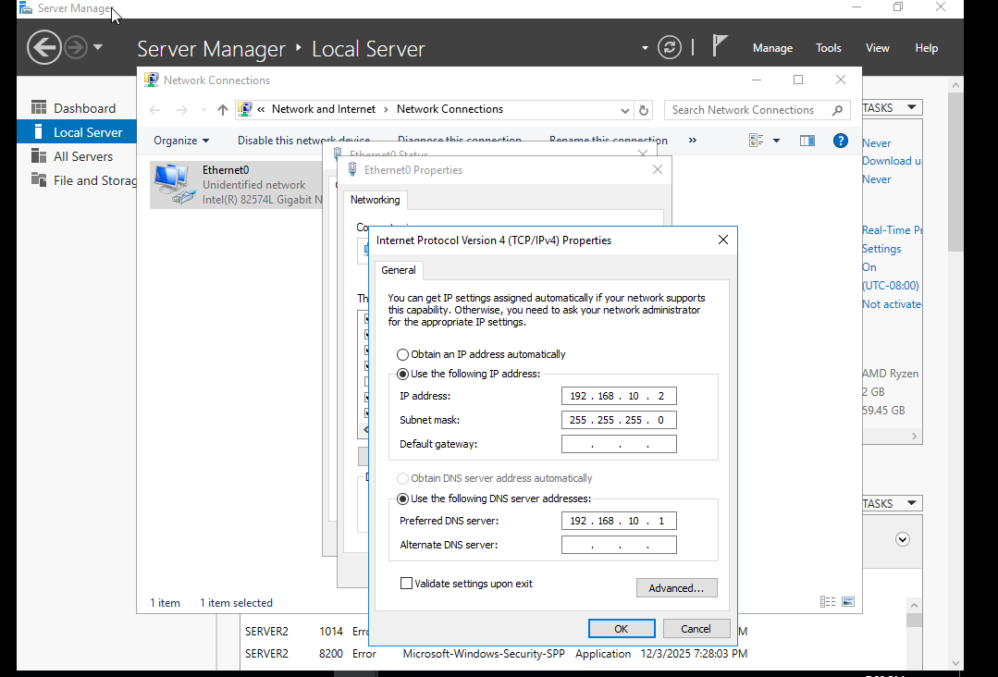
Client 1:
- Setting System Rename PC(Client1)
- Setting type Firewall go to the Windows Firewall Turned Off
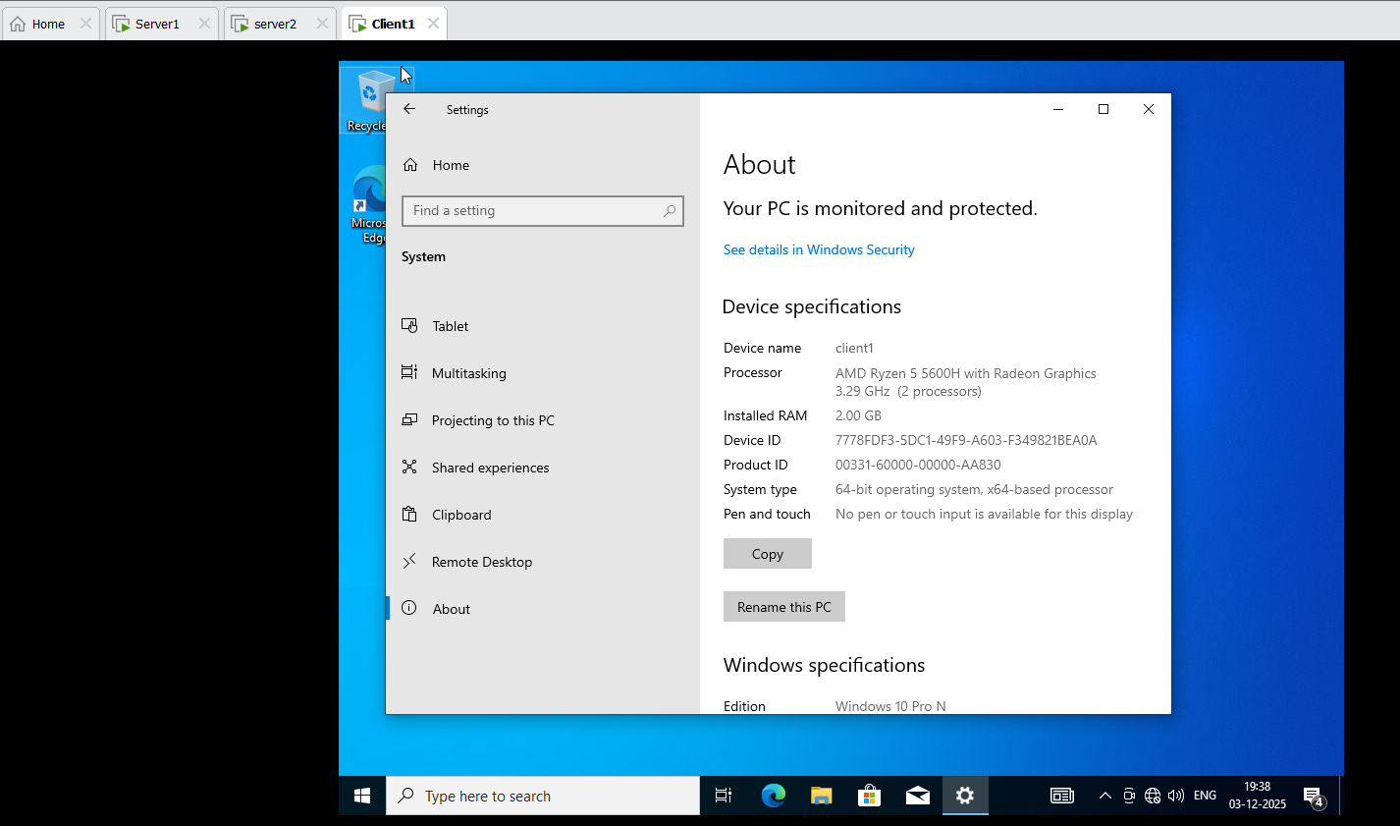
3. search Run ncpa.cpl Properties IPV4 Give the ip : – 192.168.10.3 click on subnet mask Preffered DNS Server : 192.168.10.1
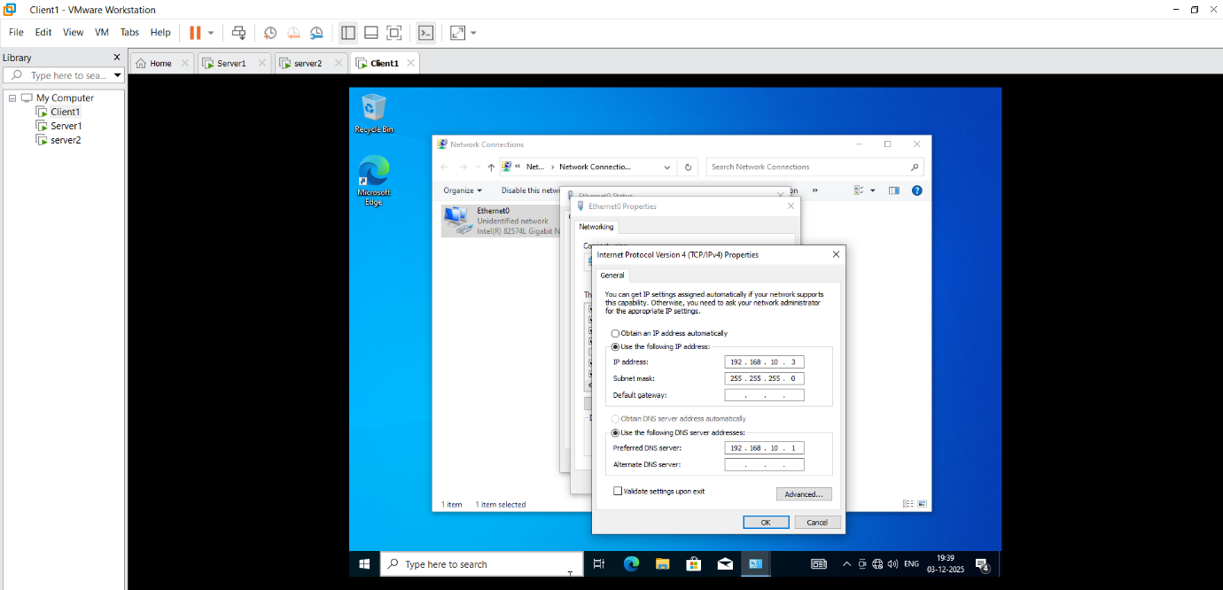
In server1 go to the cmd: ipconfig
Ping 192.169.10.2

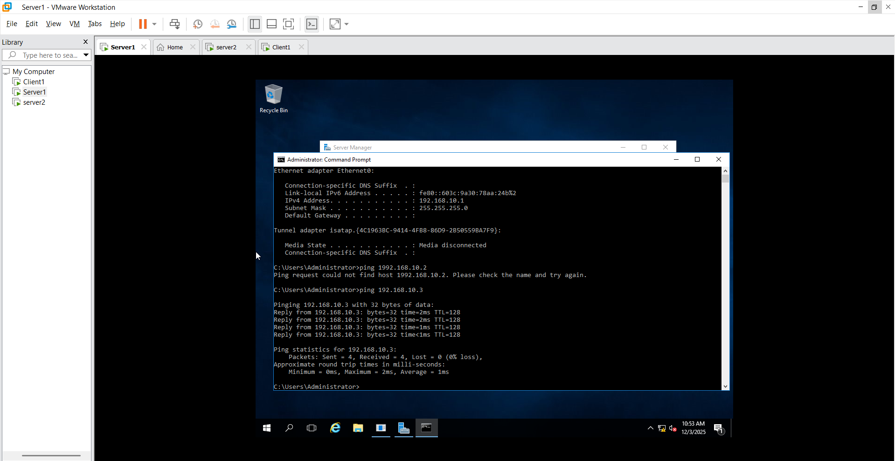
In server2 go to the cmd: ipconfig
Ping 192.169.10.1

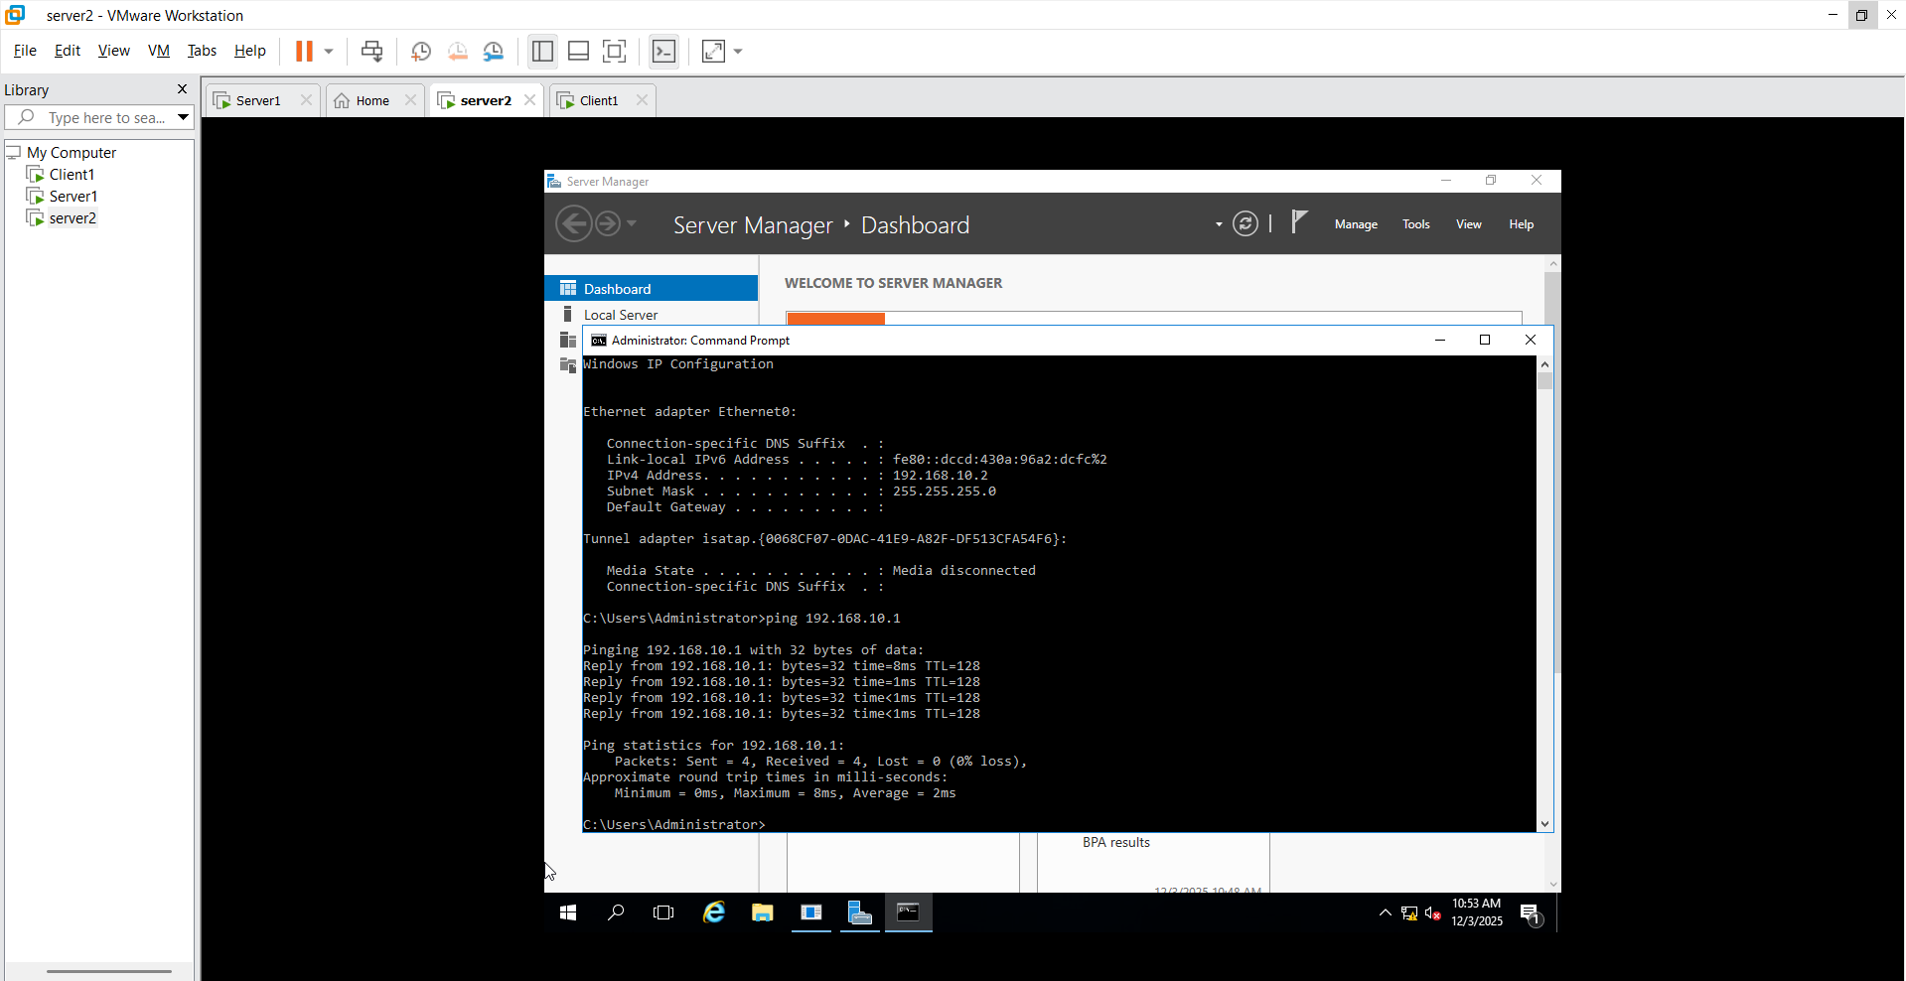
In client1 go to the cmd: ipconfig
Ping 192.169.10.2

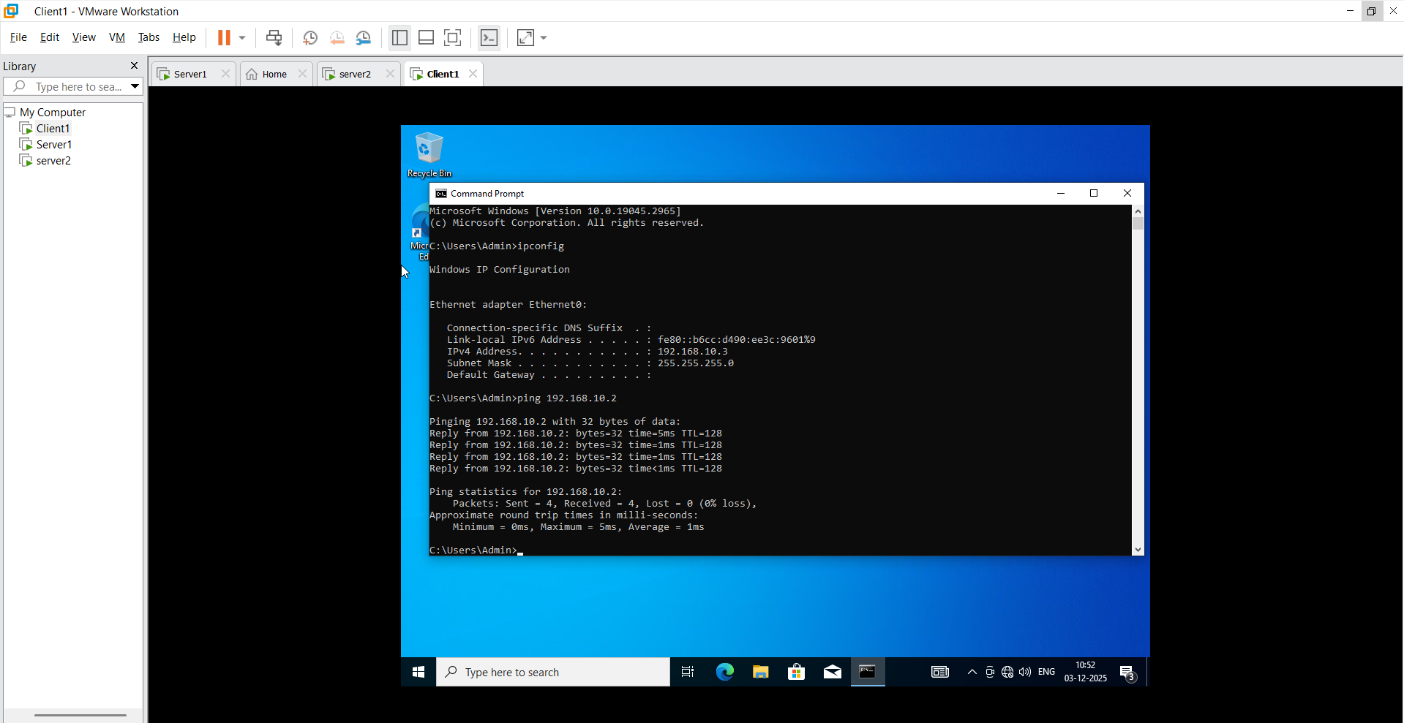

Client 1:
search Computer Management Local users and group Create 5 new user username –Admin (select user must change password at next logon)
Create Same 4 user(select password not expries)

